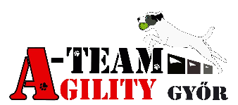
Event Registration
We would like to invite everyone to the A-Team Agility Cup
organised by A-Team SE.
The competition is OFFICIALLY accepted by MEOESZ and ASB.

Date:
17th June 2018, Sunday
Site:
Győrzámoly sports ground: https://goo.gl/maps/1axZT GPS: 47.745463, 17.581547

Classes:
A0 jumping 1, jumping 2
A1 Agility; Open agility; A2+Veteran/Hobby Agility; A3 Agility
Judges:
Pirity Árpád (A0 jumping 1-2; A1 agility)
Sabrina Hauser (A2;+Veteran/Hobby;A3 Agility; Open Agility
Should a judge be unable to fulfill the appointment to judge, the show management reserves the right to appoint another judge
Registration: Start time to be determined after the close of entries.
Competition schedule:
2xA0 jumping; 1xA1 Agility; 1xOpen Agility; 1xA2+Veteran/Hobby; 1xA3 Agility
Obstacles: All contact obstacles are aluminium with rubber cover. Tunnels made by Bing and Smart.
Awards:
Awards will be given in first through third place in every class, level and size category.
The Veteran/Hobby class categories will be merged.
If a size category contains less than 4 entries, it will be merged with the other size categories.

Entry fee:
3300Ft/12 Eur/dog, same owner's other dogs 3000 Ft/11 Eur/dog
In case of delaying payment after 8th June price is 4000 Ft/15 Eur.

Entry:

http://dogresult.com/hu/event/view/32/a-team-kupa-2018#fndtn-panel-details

Maximum number of entries: 150 pair
The competition needs at least 90 valid entries before the closing date or the event will be cancelled. A0 category requires a minimum of 15 team entries, and the Hobby/veterán classes require a minimum of 6 entries before the closing date.
Payment method: Bank transfer
Invoice owner: A-Team SE Győr Bársonyka út 10.
Invoice number: OTP Bank: 11737007-20762351
IBAN: HU34117370072076235100000000
Swift: OTPVHUHB

Please indicate the name and address exactly on the transfer.
Deadline: 2017. június 08
If the entry fee arrived the entry will be accepted.

Contact: 06-30-621-7701

More information:
- Your entry will be queued.
- Upon receipt of full payment for entry you will be put on the starting list.
- Refunds are only available due to owner or dog illness with evidence through a medical certificate. Cancelling of competition will result in a full refund.

Information for beginners:
- Important! You should choose category according to your dog's real size. (maxi dog can’t compete in midi and mini category, midi can’t compete in mini)
- Jumping height: S: 25 cm; M:35 cm L:45 cm
- Jumping obstacles: bar jump, tunnels, (chute excluded) broad jump, wall jump.
- Beginners’ race are unofficial.
- Dogs must be older than 18 months to compete. In the beginner category too!
- Beginners may use a toy in their hand. Food not allowed.
- Age of the dog will be checked via pet health record book.

Rules:
- Participation requires agility performance record book and copy of membership card.
- According to the valid Hungarian animal health rules you must confirm the valid vaccinations against rabies. If it is not possible the dog will be disqualified.
- Both inside or outside the field, rough treatment of the dog is punished by disqualification. If the dog causes injury to another dog or human it will be disqualified and the entry fee will not be refunded. The guilty dog’s owner will be responsible for all fees incurred (vet fee etc.).
- During the competition, the staffs' requests and instructions must be respected.
- Dogs not allowed in restrooms.
- Important! Smoking allowed only in smoking area. No littering!
- Please pay attention to your environment. Owners have to clean up after their dog, otherwise you will be disqualified. Please take your dog to pee to the green area outside of the sports ground.
- During the event there is a buffet at the sports ground.
- Tents and parking according to the staffs’ instructions. Tent area reservation cost 1000 Ft/person/day. Bathing facilities are provided.

Directions
- You need to leave the M1 Highway at exit no. 107 towards Győr Centrum – Vámosszabadi (road no. 14). You will be on the road no. 19. It leads you to road no. 1.
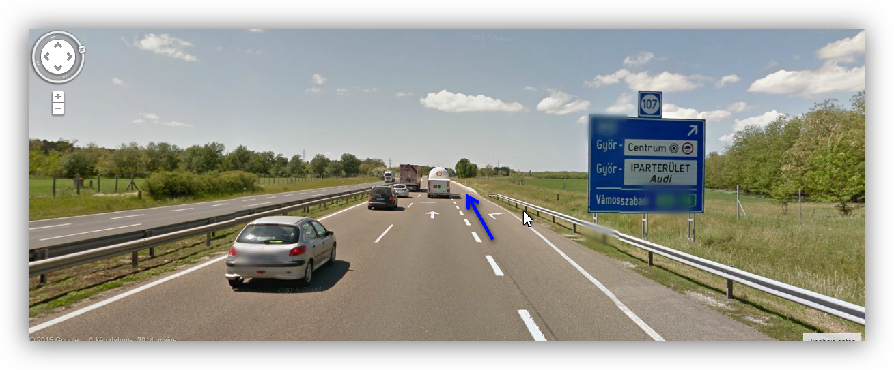
- Follow the road no. 1.. After the „Audi” roundabout you have to leave the new Audi Arena and ETO PARK (on the left side of the road). Go along toward the centrum. Soon you reach MOL gas station (in the middle of the picture). You have to turn right before the gas station and go along.
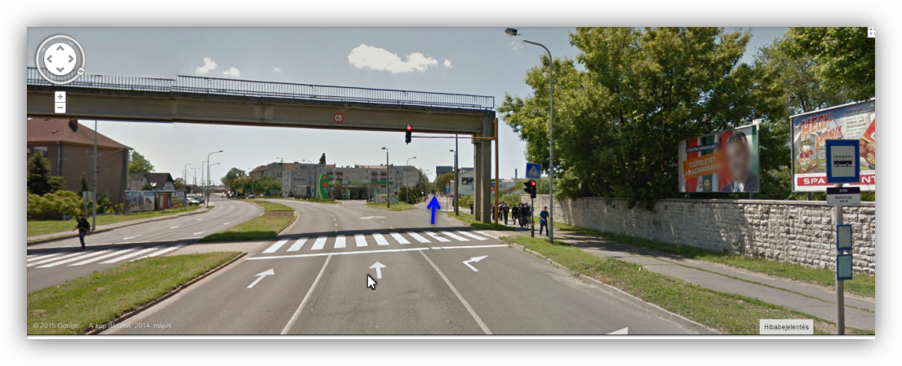

- At the next traffic lamp (Famulus Hotel will be the left side of the road and there is a railway crossing). Keep left and you will arrive at the Árkád roundabout. First exit on the right take you toward Vámosszabadi (road no. 14). You will leave ÁRKÁD. There will be the Mosoni-Duna bridge.
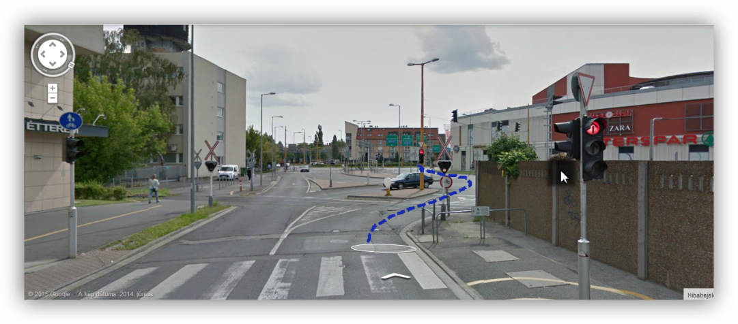

- Over the bridge at the first traffic lamp straight ahead in the direction of Szigetköz.

We look forward to seeing you. Safe travel and good luck!
A-Team SE
Pirity Árpád
Association President

